CS509: PG Software Lab

Name : Kunta Rishi
ID : 2026CSM1033

Name: Muppuri Malyadri Lakshmi Narasimha
ID: 2026AIM1014

Course: CS509 (Post Graduation Software Laboratory)
Language Platform: C++ (ISO C++26 Standard)
Development Env: Visual Studio Code (VS Code)

Directory Structure

Master/
├── common_wrapper/
│ └── wrapper.cpp # Automated test suite controller & benchmark runner
├── driver/
│ └── [algorithm].cpp # Implementation files hosting core optimization algorithms
├── src/
│ └── [module].cpp # Source scripts passing and managing data feeding driver methods
├── tests/
│ ├── test_01.txt # Sequential evaluation text matrices
│ ├── test_02.txt
│ └── test_03.txt
└── README.md # Repository documentation and comprehensive execution matrix

Gradient Discant :

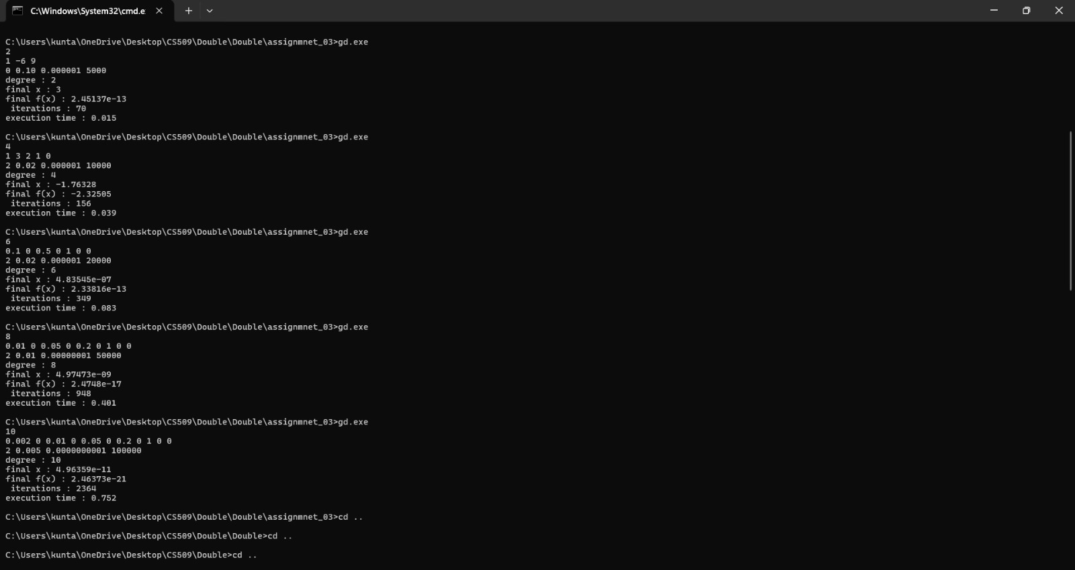

Min Max Algorithm

Test File | Vertices | Edges | Input Type | Min Max
text_10.txt | 10 | 15 | CSR | 0.017 ms
text_100.txt | 100 | 200 | CSR | 0.09786 ms
text_10000.txt | 10000 | 20000 | CSR | 12.686 ms
text_50000.txt | 50000 | 75000 | CSR | 62.9451 ms
text_1000000.txt | 1000000 | 200000 | CSR | 604.355 ms

